Chapter 19
International Monetary Systems:
A Historical Overview

■ Chapter Organization
Macroeconomic Policy Goals in an Open Economy.
Internal Balance: Full Employment and Price Level Stability.
External Balance: The Optimal Level of the Current Account.
Box: Can a Country Borrow Forever? The Case of New Zealand.
Classifying Monetary Systems: The Open-Economy Monetary Trilemma.
International Macroeconomic Policy under the Gold Standard, 1870–1914.
Origins of the Gold Standard.
External Balance under the Gold Standard.
The Price-Specie-Flow Mechanism.
The Gold Standard “Rules of the Game”: Myth and Reality.
Internal Balance under the Gold Standard.
Case Study: The Political Economy of Exchange Rate Regimes:
Conflict over America’s Monetary Standard during the 1890s.
The Interwar Years, 1918–1939.
The Fleeting Return to Gold.
International Economic Disintegration.
Case Study: The International Gold Standard and the Great Depression.
The Bretton Woods System and the International Monetary Fund.
Goals and Structure of the IMF.
Convertibility and the Expansion of Private Capital Flows.
Speculative Capital Flows and Crises.
Analyzing Policy Options for Reaching Internal and External Balance.
Maintaining Internal Balance.
Maintaining External Balance.
Expenditure-Changing and Expenditure-Switching Policies.
The External Balance Problem of the United States under Bretton Woods.
Case Study: The End of Bretton Woods, Worldwide Inflation, and the Transition to Floating Rates.
The Mechanics of Imported Inflation.
Assessment.
The Case for Floating Exchange Rates.
Monetary Policy Autonomy.
Symmetry.
Exchange Rates as Automatic Stabilizers.
Exchange Rates and External Balance.
Case Study: The First Years of Floating Rates, 1973–1990.
Macroeconomic Interdependence under a Floating Rate.
Case Study: Transformation and Crisis in the World Economy.
Box: The Thorny Problem of Currency Manipulation.
Case Study: The Dangers of Deflation.
What Has Been Learned Since 1973?
Monetary Policy Autonomy.
Symmetry.
The Exchange Rate as an Automatic Stabilizer.
External Balance.
The Problem of Policy Coordination.
Are Fixed Exchange Rates Even an Option for Most Countries?

Summary
APPENDIX TO CHAPTER 19: International Policy Coordination Failures

■ Chapter Overview
This is the first of four international monetary policy chapters. These chapters complement the preceding theory chapters in several ways. They provide the historical and institutional background students require to place their theoretical knowledge in a useful context. The chapters also allow students, through study of historical and current events, to sharpen their grasp of the theoretical models and to develop the intuition those models can provide. (Application of the theory to events of current interest will hopefully motivate students to return to earlier chapters and master points that may have been missed on the first pass.)
Chapter 19 chronicles the evolution of the international monetary system from the gold standard of 1870–1914, through the interwar years, the post-World War II Bretton Woods regime that ended in March 1973, and the system of managed floating exchange rates that have prevailed since. The central focus of the chapter is the manner in which each system addressed, or failed to address, the requirements of internal and external balance for its participants. A country is in internal balance when its resources are fully employed and there is price level stability. External balance implies maintaining a level of the current account that allows the most important gains from trade to be realized over time without risking a debt crisis (excessive current account deficit) or limiting domestic investment (excessive current account surplus). Governments may not know exactly what the optimal time path of the current account should be, so they generally try to avoid excessive current account deficits or surpluses.
Underlying each of these exchange rate systems is the “open economy trilemma,” the observation that you can have two, but never three, of the following: exchange rate stability, independent monetary policy, and free capital mobility. Whereas the gold standard traded independent monetary policy for exchange rate stability and capital mobility, the Bretton Woods system allowed for autonomous monetary policy by limiting capital flows. The modern era of floating exchange rates sacrifices currency stability in exchange for independent monetary policy and capital mobility.
The gold standard of 1870-1914 had several strengths and weaknesses. The primary responsibility of the central bank under the gold standard was to fix the exchange rate between its currency and gold. External balance was seen as the situation in which the country was neither gaining too much gold from abroad nor losing too much gold to foreign countries. The “rules of the game” under the gold standard instructed central banks to sell domestic assets when experiencing outflows of gold (raising interest rates and attracting foreign capital) and to buy domestic assets when experiencing inflows of gold (lowering interest rates and incentivizing capital outflows). In practice, there was little incentive for countries with expanding gold reserves to follow these “rules of the game.” This increased the contractionary burden shouldered by countries with persistent current account deficits. The gold standard also subjugated internal balance to the demands of external balance. Research suggests price level stability and high employment were attained less consistently under the gold standard than in the post-1945 period.

The interwar years were marked by severe economic instability. The monetization of war debt and of reparation payments led to episodes of hyperinflation in Europe. An ill-fated attempt to return to the prewar gold parity for the pound led to stagnation in Britain. Competitive devaluations and protectionism were pursued in a futile effort to stimulate domestic economic growth during the Great Depression. These beggar-thy-neighbor policies provoked foreign retaliation and led to the disintegration of the world economy. As one of the case studies shows, strict adherence to the gold standard appears to have hurt many countries during the Great Depression.
Determined to avoid repeating the mistakes of the interwar years, Allied economic policy makers met at Bretton Woods in 1944 to forge a new international monetary system for the postwar world. The exchange-rate regime that emerged from this conference had at its center the U.S. dollar. All other currencies had fixed exchange rates against the dollar, which itself had a fixed value in terms of gold. An International Monetary Fund was set up to oversee the system and facilitate its functioning by lending to countries with temporary balance of payments problems.
A formal discussion of internal and external balance introduces the concepts of expenditure-switching and expenditure-changing policies. The Bretton Woods system, with its emphasis on infrequent adjustment of fixed parities, restricted the use of expenditure-switching policies. Increases in U.S. monetary growth to finance fiscal expenditures after the mid-1960s led to a loss of confidence in the dollar and the termination of the dollar’s convertibility into gold. The analysis presented in the text demonstrates how the Bretton Woods system forced countries to “import” inflation from the United States and shows that the breakdown of the system occurred when countries were no longer willing to accept this burden.
Following the breakdown of the Bretton Woods system, many countries moved toward floating exchange rates. In theory, floating exchange rates have four key advantages: They allow for independent monetary policy; they are symmetric in terms of the costs of adjustment faced by deficit and surplus countries; they act as automatic stabilizers that mitigate the effects of economic shocks; and they help maintain external balance through stabilizing speculation that depreciates the currency of a country with a large current-account deficit.
These advantages must be matched with the experience of countries running floating exchange rate regimes. Floating exchange rates should give countries greater autonomy over monetary policy. However, the evidence suggests that changes in monetary policy in one country do get transmitted across borders, limiting autonomy. Second, exchange rates have become less stable. For example, in the mid-1970s, the United States chose to pursue monetary expansion to fight a recession, whereas Germany and Japan contracted their money supplies to counter inflation. As a result, the dollar sharply depreciated against these currencies. The symmetry benefit of floating rates is also limited by the fact that the dollar still serves as the world’s reserve currency, much as it did under Bretton Woods. Although floating rates do work as automatic stabilizers, the effects may be unevenly distributed within countries. For example, the U.S. fiscal expansion of the 1980s appreciated the dollar, limiting inflation overall. However, U.S. farmers were hurt by this action as the stronger dollar weakened exports. With immobile factors of production, these asymmetric effects can have long-run consequences. Finally, empirical evidence suggests that external imbalances have actually increased since the adoption of floating exchange rates. The chapter concludes with a discussion of policy coordination under floating exchange rates. For example, a large country with a current-account deficit that attempts to reduce its imbalance could cause global deflation. There is also a market failure at work here in that policies by one country have external effects. For example, the 2007–2009 financial crisis sparked a number of fiscal expansions in countries. Increased government spending in the United States, for example, helped lift demand not just in the United States but in other countries as well. Another example is the worldwide economic contraction triggered by the COVID-19 pandemic. Output and trade fell considerably around the world, leading to significantly higher unemployment. Countries differed in terms of both the timing and extent of their responses to the pandemic. Some countries aggressively shut down their economies while others remained open. Some countries experienced much higher infection and mortality rates than others. Countries also differed in terms of the magnitude of their fiscal response to the economic slowdown. Given the interconnectedness of the global economy, these differential policies have had spillover effects across borders.
Because the benefits of fiscal expansion are not fully internalized (though the costs are through accumulated budget deficits), there will be an inefficiently small expansion from a global perspective. Thus, international policy coordination, even in a world of flexible exchange rates, may still be warranted. This is especially relevant given the observation that given increased capital mobility, fixed exchange rates may not even be an option for most countries in a world without international coordination of monetary policy.
■ Answers to Textbook Problems
1. a. Because it takes considerable investment to develop uranium mines, you would want a larger current-account deficit to allow your country to finance some of the investment with foreign savings.
b. A permanent increase in the world price of copper would cause a short-term current account deficit if the price rise leads you to invest more in copper mining. If there are no investment effects, you would not change your external balance target because it would be optimal simply to spend your additional income.
c. A temporary increase in the world price of copper would cause a current account surplus since you would likely not increase investment in response to a temporary price increase. Rather, your exports would increase in value as the price of your main export increases. You would want to smooth out your country’s consumption by saving some of its temporarily higher income.
d. A temporary rise in the world price of oil would cause a current account deficit if you were an importer of oil, but a surplus if you were an exporter of oil.
2. Because the marginal propensity to consume out of income is less than 1, a transfer of income from B to A increases savings in A and decreases savings in B. Therefore, A has a current account surplus and B has a corresponding deficit. This corresponds to a balance of payments disequilibrium in Hume’s world, which must be financed by gold flows from B to A. These gold flows increase A’s money supply and decrease B’s money supply, pushing up prices in A and depressing prices in B. These price changes cease once the balance of payments equilibrium has been restored.
3. Changes in parities reflected both initial misalignments and balance of payments crises. Attempts to return to the parities of the prewar period after the war ignored the changes in underlying economic fundamentals that the war caused. This made some exchange rates less than fully credible and encouraged balance of payments crises. Central bank commitments to the gold parities were also less than credible after the wartime suspension of the gold standard and as a result of the increasing concern of governments with internal economic conditions.
4. A monetary contraction, under the gold standard, will lead to an increase in the gold holdings of the contracting country’s central bank if other countries do not pursue a similar policy. All countries cannot succeed in doing this simultaneously because the total stock of gold reserves is fixed in the short run. Under a reserve currency system, however, a monetary contraction causes an incipient rise in the domestic interest rate, which attracts foreign capital. The central bank must accommodate the inflow of foreign capital to preserve the exchange rate parity. There is thus an increase in the central bank’s holdings of foreign reserves equal to the fall in its holdings of domestic assets. There is no obstacle to a simultaneous increase in reserves by all central banks because central banks acquire more claims on the reserve currency country while their citizens end up with correspondingly greater liabilities.
5. The increase in domestic prices makes home exports less attractive and causes a current account deficit. This diminishes the money supply and causes contractionary pressures in the economy, which serve to mitigate and ultimately reverse wage demands and price increases.
6. An increase in the world interest rate leads to a fall in a central bank’s holdings of foreign reserves as domestic residents trade in their cash for foreign bonds. This leads to a decline in the home country’s money supply. The central bank of a “small” country cannot offset these effects because it cannot alter the world interest rate. An attempt to sterilize the reserve loss through open market purchases would fail unless bonds are imperfect substitutes.
7. Capital account restrictions insulate the domestic interest rate from the world interest rate. Monetary policy, as well as fiscal policy, can be used to achieve internal balance. Because there are no offsetting capital flows, monetary policy, as well as fiscal policy, can be used to achieve internal balance. The costs of capital controls include the inefficiency, which is introduced when the domestic interest rate differs from the world rate, and the high costs of enforcing the controls.
  - We are given that the growth rate in GDP may be computed as g = (GDP_{t + 1} − GDP_{t})/GDP_{t}. Solving for GDP in time t + 1 yields: GDP_{t + 1} = GDP_{t}(1 + g). Using this expression alongside that derived for IIP_{t + 1} allows us to compute:
IIP_{t + 1}/GDP_{t + 1} = [(1 + r)IIP_{t} + NX_{t}]/[GDP_{t}(1 + g)] = [(1 + r)iip_{t} + nx_{t}]/(1 + g), where lower case variables denote ratios to GDP.
To find the ratio of net exports to GDP that keeps the ratio of IIP to GDP constant, we simply need to solve the equation IIP_{t}/GDP_{t} = IIP_{t + 1}/GDP_{t + 1} → iip_{t} = [(1 + r)iip_{t} + nx_{t}]/(1 + g).
Taking this equation and solving for nx_{t} yields nx_{t} = iip(g − r). In order for the international investment position as a fraction of GDP to stay constant, net exports must grow at a rate equal to the GDP growth rate less the interest rate earned (paid) on foreign assets (liabilities).
9. a. We know that China has a very large current-account surplus, placing them high above the XX line. They also have moderate inflationary pressures (described as “gathering” in the question, implying they are not yet very strong). This suggests that China is above the II line but not too far above it. It would be placed in zone 1 (see below).

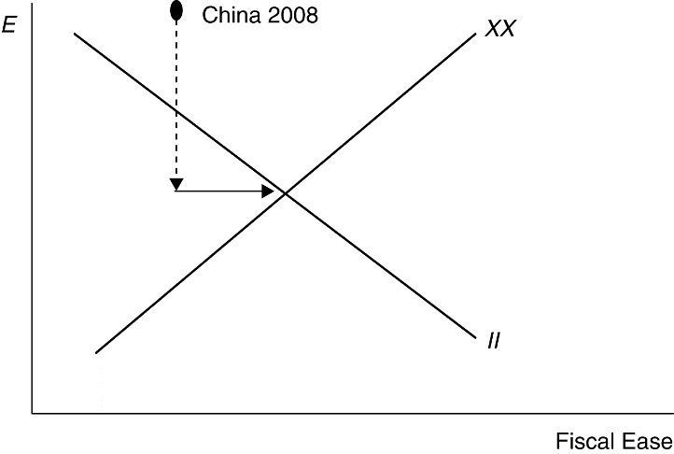
b. China needs to appreciate the exchange rate to move down on the graph toward the balance. (Shown on the graph with the dashed line down.)
c. China would need to expand government spending to move to the right and hit the overall balance point. This would expand the low level of government services and provide employment opportunities for workers moving from rural to urban areas. Such a policy would help cushion the negative aggregate demand pressure that the appreciation might generate.
10. The increase in foreign prices will shift the DD curve out to the right as demand for home products increases (exports rise, imports fall). If the expected exchange rate also falls, then there will be a leftward shift in the AA curve as foreign assets pay a lower home currency return. In the end, the home currency will appreciate by the same proportion as the increase in foreign prices, leaving output unchanged. There will be no change in the country’s internal or external balance.

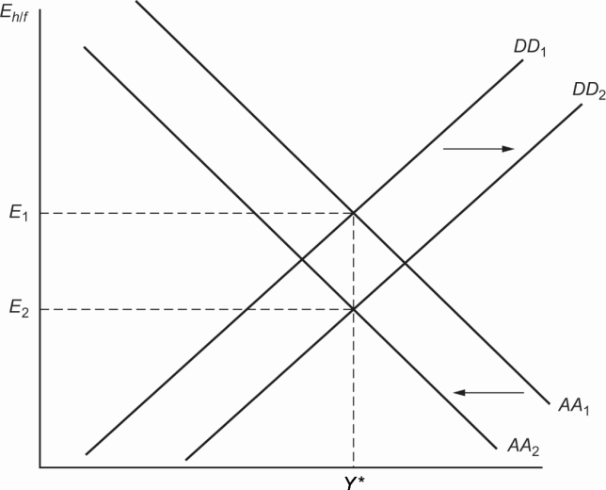
  - An increase in the foreign inflation rate should lead to a short-run appreciation of the domestic currency as consumers shift their consumption toward relatively cheaper domestic goods. The appreciation of the domestic currency will mitigate the effects of foreign inflation by reducing the price of imported goods. Thus, the flexible exchange rate does a better job of insulating the economy from foreign inflation than a fixed exchange rate would.
In the long run, the increase in foreign inflation will work through relative PPP to cause home interest rates to fall relative to domestic rates. We can see this by combining the interest rate parity condition: %ΔE_{h/f} = R_{h} − R_{f} with the relative PPP condition: %ΔE_{h/f} = π_{h} − π _{f} to get: π_{h} − π _{f} = R_{h} − R _{f}. Thus, an increase in π_{f} will cause R_{h} − R_{f} to fall proportionately.
  - An increase in the risk premium on domestic assets will shift the AA curve to the right, reflecting the fact that asset market equilibrium is now attained at a higher exchange rate (depreciated domestic currency). With floating exchange rates, the depreciated currency will stimulate export demand, leading to a movement along the DD curve until general equilibrium is restored at both a depreciated currency (E₂) and higher level of output (Y₂). With a fixed exchange rate, the central bank would have to respond to the higher risk premium on domestic assets by raising domestic interest rates to keep the exchange rate constant at E₁. As a result, the AA curve would shift back to its original level, and output would remain unchanged. Thus, the effect on output would be smallest for a fixed exchange-rate regime.

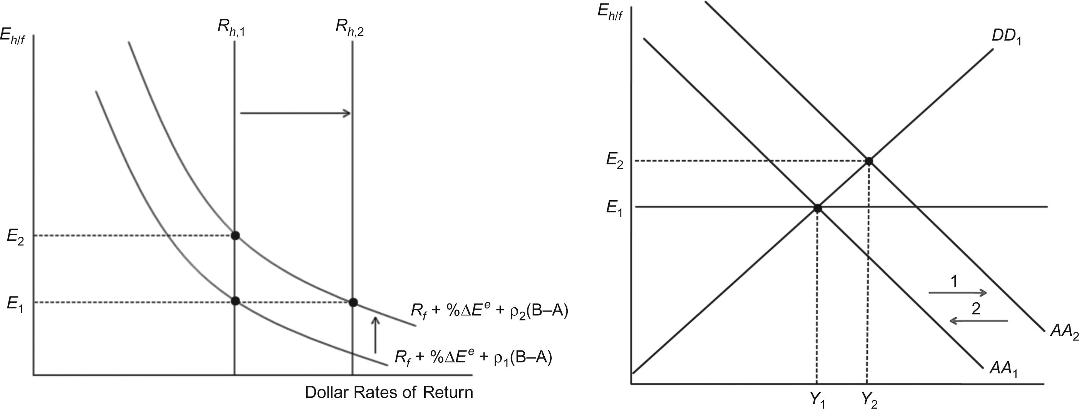

13. The simple model of savings and investment against the real interest rate can be drawn as shown below. The increase in world savings can be shown as a rightward shift in the savings schedule. The result is that the world real interest rate falls and the amount of savings and investment rises. We can think of the “global savings glut” story here. World interest rates went down as large-scale savings (public and private), in emerging market countries in particular, increased the supply of world savings. This falling interest rate should lead to an increase in world investment. If this investment is in countries other than the ones who increased savings, then the increased investment and constant savings (or possibly falling savings due to the falling world real interest rate) in countries like the United States will lead to current account deficits in the United States and like countries and current account surpluses in the savings countries.

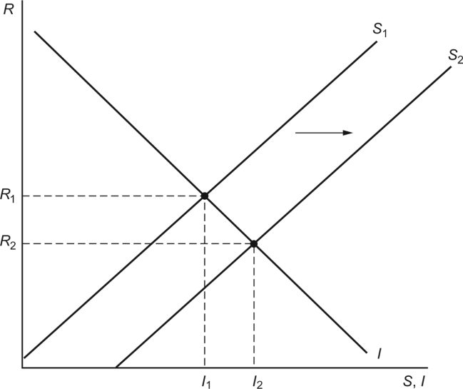

14. The table below shows U.S. prime lending interest rates and inflation rates from 1970 to 1976. This data comes from the St. Louis Federal Reserve database of economic data accessible at https://fred.stlouisfed.org/. Assuming that expected inflation equals actual inflation, we can generate the real interest rates. The first oil shock starts at the end of 1973, so 1974 is the first year we would see its effects. The three years following the oil shocks have lower real interest rates (negative in 1974) as compared to real interest rates before the shock, consistent with the theory.
Year | Nominal Interest Rate (percent per year) | Inflation  (percent per year) | Real Interest Rate  (percent per year)
1970 | 7.9 | 6.6 | 1.3
1971 | 5.7 | 3.1 | 2.6
1972 | 5.3 | 3.0 | 2.3
1973 | 8.0 | 4.7 | 3.3
1974 | 10.8 | 11.3 | −0.5
1975 | 7.9 | 6.7 | 1.2
1976 | 6.8 | 6.1 | 0.7
15. If other central banks sell dollars for euros, then it is equivalent to a sterilized sale of dollars because neither the United States nor any other central bank’s asset side of the balance sheet has changed. Thus, the money supply is unchanged everywhere. On the other hand, there is a larger supply of dollar assets relative to euro assets in circulation than before. If this is not viewed as a signal of U.S. or euro area monetary policy and assets are substitutable, there should be no impact on the exchange rate. If the action moves the risk premium on U.S. assets because the outstanding supply becomes too large (and assets are not perfectly substitutable, see Chapter 18), the action could cause a depreciation of the dollar against the euro.
16. It should be noted that current link is actually https://www.abs.gov.au/statistics. Students may find navigating the Australian Bureau of Statistics website challenging, given the large volume of information available on this site. That said, once the data has been collected, the solution to this problem is fairly straightforward.
From problem 8, we know that the international investment position as a share of GDP will be constant when iip = nx/(g − r). Using this equation, solve for the interest rate that keeps iip constant when nx and g are at their historical averages:
r = g − nx/iip
Collecting annual data on nominal GDP, NX, and IIP from the Australian Bureau of Statistics from 1992 through 2020 gives average annual growth rate in nominal GDP of g = 5.50% and an average net exports to GDP ratio of nx = −0.65%. In 2020, the ratio of IIP to GDP was −48.23%. Thus, to maintain this IIP ratio, the interest rate earned (paid) on Australia’s foreign assets (liabilities) must be:
r = 5.50% − (0.65%/48.23%) = 4.15%

